**MATHEMATICS APPLICATIONS**

**Test 3 2018**

**Area, Surface Area, Volume and Similarity**

**Section A-Resource Free**

**Marks: 17 Time Allowed: 20 minutes**

**Total Marks: / 54**

**Name: _______________**

**ALL** working must be shown for full marks.

**Answers must be rounded to 2dp where appropriate**

**Question 1 [4 marks]**

If **a** = 4 and **b** = -2

1. 2**a** + 3**b** = **b)**  30 + **ab** =

**c)** 5(**a** – **b**) = **d) a**2 + **b**2=

**Question 2 [4 marks]**

Convert the following units of measurement.

1. 259000mm = m **b)**  0.042km2 = m2

**c)** 6.5m3 = L **d)** 3500ha = km2

**Question 3** **[2 marks]**

The triangular prism below has a volume of is 66cm3. Calculate the volume of a triangular pyramid that has the same base area and height as the prism below.

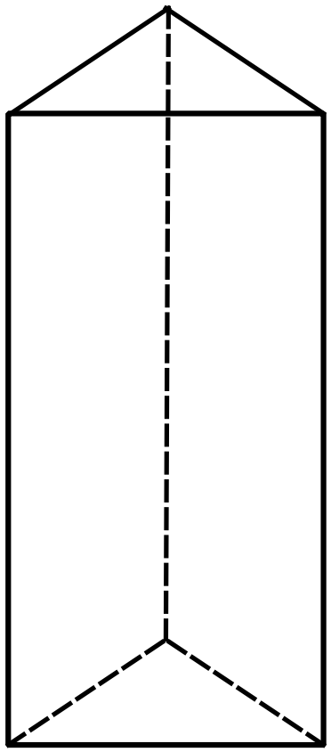

**Question 4**  **[7 marks]**

1. Identify which pairs of triangles are Similar and state the similarity test that applies.
2. Calculate the Scale Factor where the similar triangles occur.
3. Give the value for the missing letters where the similar triangles occur.

**i)**

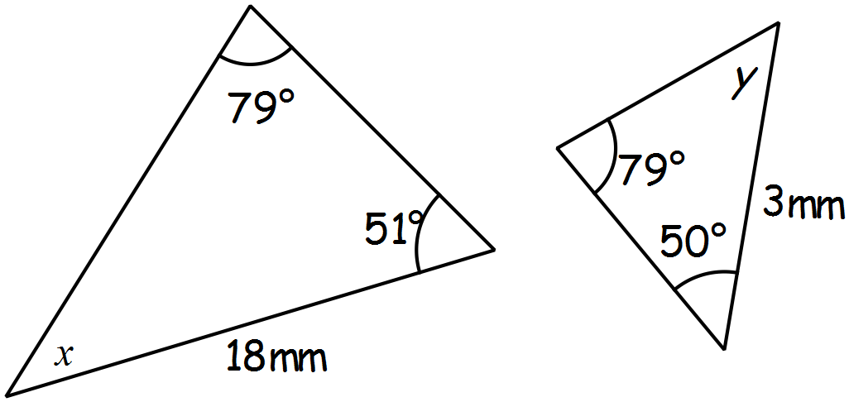

**ii)**

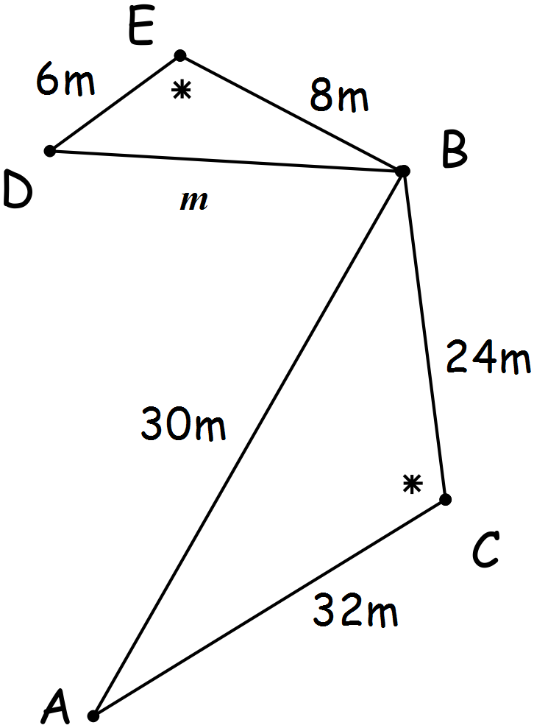

**MATHEMATICS APPLICATIONS**

**Test 3 2018**

**Linear Functions**

**Section B-Resource Assumed**

**Marks: 37 Time Allowed: 40 minutes**

**ALL** working must be shown for full marks.

**Answers must be rounded to 2dp where appropriate**

**Question 5** **[1, 2, 2 = 5 marks]**

**For the following shape**

1. Calculate the diameter of the semicircle

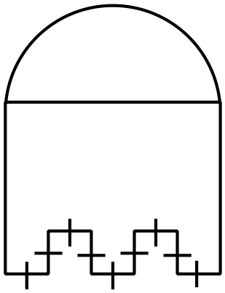

19cm

1. Calculate the perimeter

4cm

1. Calculate the area

**Question 6 [3, 3 = 6 marks]**

A cone has a volume of 24.74cm3 and a radius of 15mm.

1. Calculate the height of the cone in mm.
2. Calculate the total surface area of the cone.

**Question 7** **[2, 3, 5 = 10 marks]**

The diagrams below show two possible plans for a garden outside a new medical center. The garden beds are shown in the diagrams as grey.

Diagram 1 Diagram 2

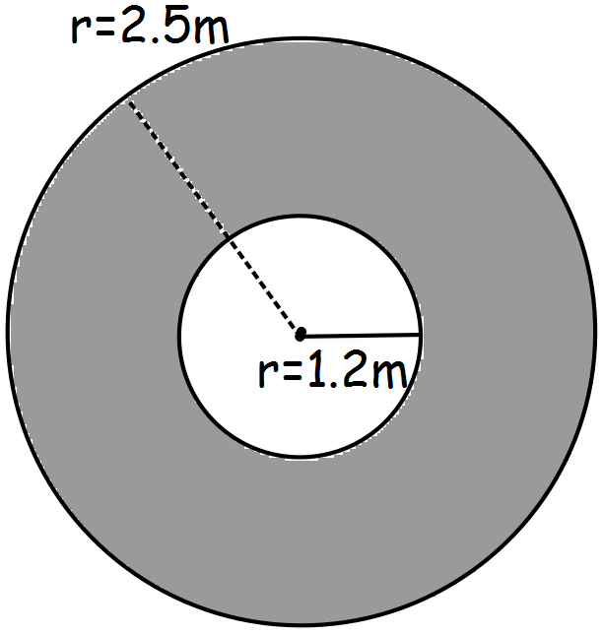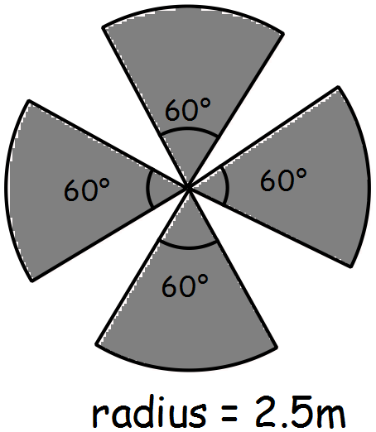

1. Calculate the perimeter of each garden.
2. A low fence is to be placed around each section of the garden which will cost $15 per metre for garden 1 and $20 per metre for garden 2. Use your answers from **a)** to calculate the cost of fencing the two gardens and decide the most cost effective design.



1. If fertilizer costs $5.50 per square meter calculate the cost of keeping each garden healthy and state which garden will be cheapest to keep healthy?

**Question 8 [1, 4, 2, 2 = 9 marks]**

For the rectangular prism below

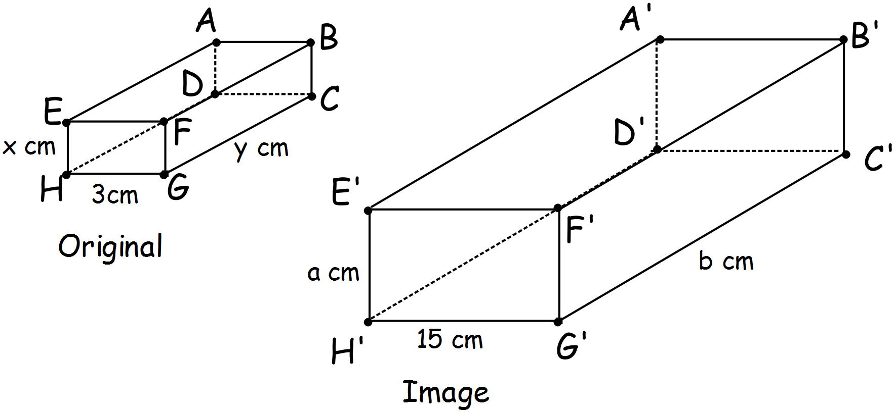

1. Calculate the scale factor that has been used to produce the image.
2. If the volume of the original prism is 24cm3 and each side is an integer (a whole number)

**i)** give the possible values for **x**, **y**

**ii)** from your values for **x**, **y** above, calculate **a** and **b**.

1. If the volume of the original prism is 30cm3 calculate the volume and capacity for the image.
2. If the surface area of the image is 1050cm2, calculate the surface area for the original prism.

**Question 9 [ 2, 2, 1, 2 = 7 marks]**

The building plan for a doctor’s office is shown in the scale diagram below.

Answer the following questions relating to this plan.

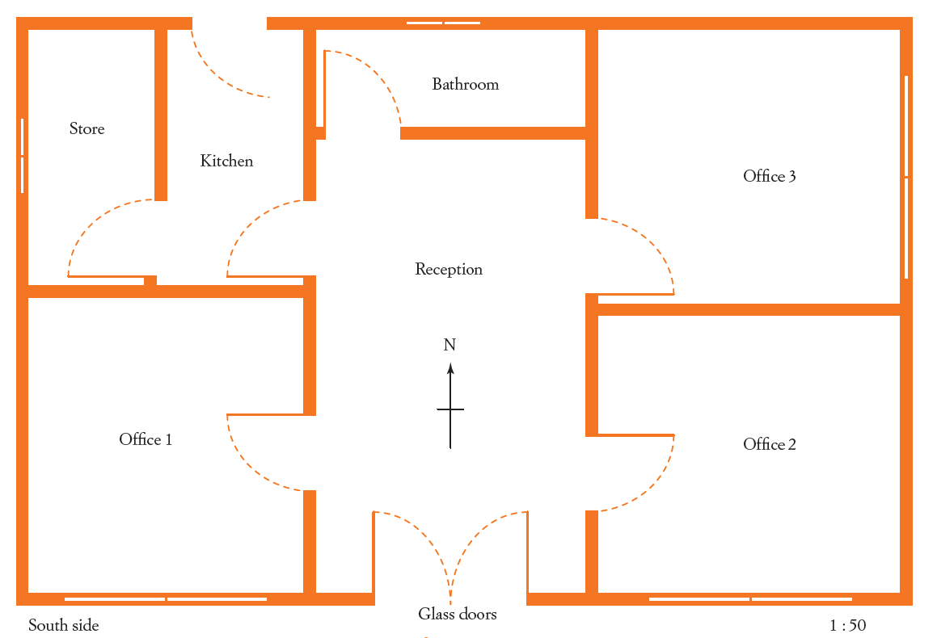

1:100

1. Calculate the length and width for the real office building.

The concrete for the floor of the building needs to be 150mm thick.

1. Find the volume of concrete needed to build the floor.
2. If concrete costs $75 per cubic metre, calculate the cost of the concrete slab.
3. Dr South would like his surgery in Office 1, he has selected the cheerful yellow carpet at a cost of $27.50 per square metre. Calculate the cost of carpeting Dr South’s office.